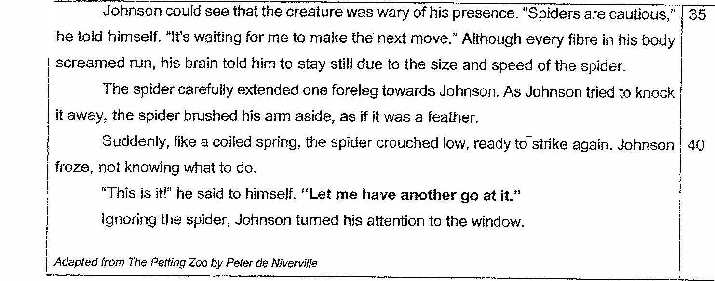

71. What was Johnson hesitating about? (1m)

tt

ep tt

(2.sitate the two conditions in the barn that caused Johnson to change his mind. (2m)

a

73.Why did Johnson have to stop to catch his breath? (21m)

TO LA yyy py pre

A A NN rE rrp ee

#4. Which two words from lines 8-14 show that Johnson was cautious while he was trapped?

The words are found in two separate sentences. [2m]